|  |  |  |  |  |
| --- | --- | --- | --- | --- |
| Week | Unit: Shapes | Grammar | Vocabulary | Useful phrases |
| *Week 2*  June  8th to 12th | Color and describe orally the shapes you see.  Complete the Crossword puzzle. | * Verb **to have** in 3rd person singular. * Articles a-an * Adjectives before colors * Colors before nouns   ***Ex-a small green circle***. | * Shapes * Colors * Verb **to have** in 3rd person singular.   Ex: The robot **has** 2 blue circles, a red triangle, 5 orange rectangles **and** a white oval. | * Let’s listen. * Let me think... * I need time, please. * I think it is … |

1. **Finish the description of the robot *orally.***

Ex: This robot has 2 small blue rectangles, a big yellow square...

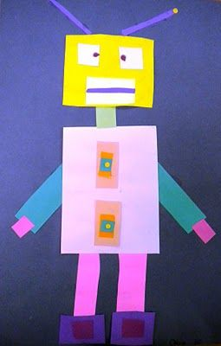

1. **Complete the crossword puzzle. Have fun 😊**

